## GAME DESIGN DOCUMENT – VR 360 VIDEO QUIZ GAME

**Game concept**

Quiz game that takes place in a 360-degree video experience.

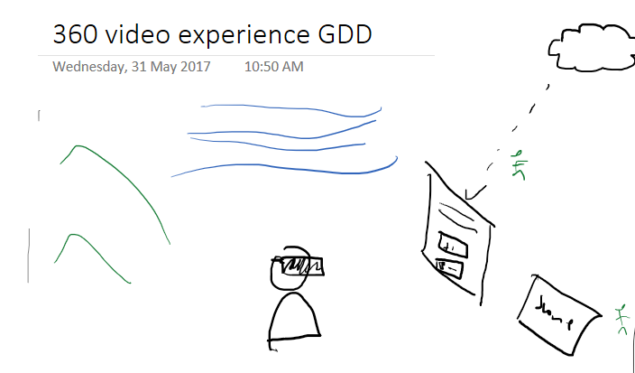

**Target platforms**

* Unity’s native VR (VR Standard Assets)
* Cross-platform: all main platforms
* Mobile VR and desktop VR
* Seated/standing up experience

**UI**

* Reticle (gaze-based input)
* 3D Panels, text, buttons

**Game mechanics**

* Video will be playing and it will be paused when a question comes up
* The user has to answer, they will get response
* After answering the video will continue player
* Video will be looping
* At the end of the quiz you will be notified and see your score

**Assets**

* 360 video
* Questions / answers (will come from URL)
* Reticle / VR Standard Assets
* Panels